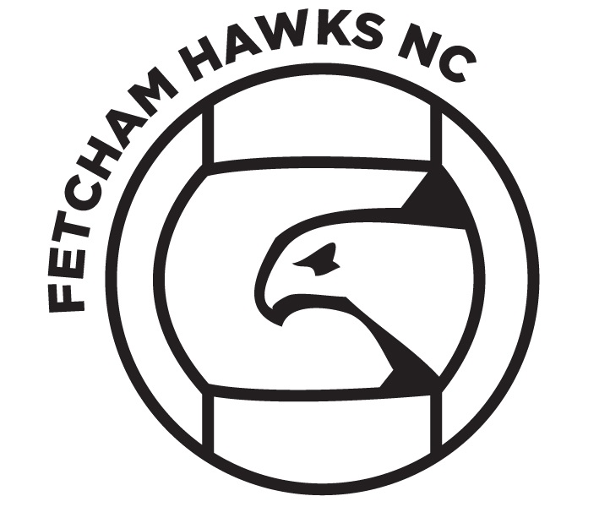

England Netball has Codes of Conduct across all aspects of the sport, which is driven by its’ core values of leadership, integrity, teamwork and excellence. We have adopted their code of conduct for our coaches, players and parents/guardians. These codes require the highest standards of conduct from everyone involved in Fetcham Hawks Netball Club to ensure that their behaviour and actions meet the values and standards expected of them at all times.

**As an athlete I will:**

 be affiliated to EN and comply with all rules, regulations and requirements of the sport including

any leagues and competitions in which I participate

 respect the rights, dignity and worth of all people involved in netball, regardless of gender, marital status, race, colour, disability, sexuality, age, occupation, religion or political opinion

 not abuse or misuse any relationship of trust, or position of power, or influence held by me within my team, club, League, County, Regional or National Association

 always conduct myself in an appropriate manner

 cooperate with my Coaches, team mates, Officials and Administrators

 never argue with an official during a game

 control my temper; I understand that verbal, emotional and physical abuse of Officials, Coaches, Spectators or other athletes, or deliberately distracting or provoking an opponent is not acceptable or permitted behaviour in netball

 treat all athletes with respect, never bully or take unfair advantage of another athlete

 work equally hard for myself and my team, show my determination and passion to learn and do

well

 display modesty in victory and graciousness in defeat

1. turn up on time to training and matches
2. turn up in appropriate kit for netball

* abide by any disciplinary sanctions that might be imposed on me
* promote this code of conduct to other athletes, especially those new to the sport of netball

**I will not:**

 consume alcoholic drinks, or illegal substances, or smoke either immediately prior to or whilst playing

 use Social Media technology to bring the game into disrepute or make an inappropriate comment about a fellow athlete, Coach, Official, volunteer or the NGB.

**By signing Fetcham Hawks registration form I agree to abide by this code**

Fetcham Hawks Junior Netball Code of Conduct

**As a Coach/Official or Volunteer I will:**

 be affiliated to EN and comply with all rules, regulations and requirements of the sport including any leagues and competitions

 respect the rights, dignity and worth of all people involved in netball, regardless of gender, marital status, race, colour, disability, sexuality, age, occupation, religion or political opinion

 not abuse or misuse any relationship of trust or position of power or influence held by me within my Team, Club, League, County, Regional or National Association

 always conduct myself in an appropriate manner

 treat all athletes, Coaches and Officials with respect, never bully or take unfair advantage

 control my temper; I understand that verbal, emotional, and physical abuse of coaches, athletes, spectators, or other officials is not acceptable or permitted behaviour in netball

 be a positive role model for netball by acting in a way that projects a positive image of coaching and being fair, considerate and honest with athletes

* display high standards in my language, manner, punctuality, preparation and presentation ensuring that an athlete’s time spent with me is a positive experience
* exercise reasonable care and skill when carrying out my duties
* abide by the “safeguarding best practice guidelines” for children and young people
* For Coaches Only

 accurately represent personal coaching qualifications, experience and competence

 keep up to date with the latest coaching practice and developments by taking up further coach education and other personal and professional development opportunities

 ensure that the training and/or competition environment is safe and appropriate for the age, physical and emotional maturity, experience and ability of the athletes

 provide a modified training programme for sick and injured athletes and encourage them to seek medical advice where required

 **As a coach/official/volunteer I will not:**

 consume alcoholic drinks or illegal substances or smoke around athletes

 wager on any match or at any event where I am coaching

 offer or attempt to offer, or accept either directly or indirectly, any consideration whatsoever with a view to influencing the result of any match

 disclose any confidential information relating to athletes without their prior consent

 use Social Media technology to bring the game into disrepute or make an inappropriate comment about a fellow Coach, athlete, Official, volunteer or the NGB

Signed by...............................................Position.........................................Date

**Coaches, officials and volunteers code of Conduct**

**If we feel the code of conduct has been broken by player, coach or parent/guardian a written warning will be issued. For a serious breech or repeated breaking of the code, expulsion from the club with immediate effect and no refund of membership will be considered at the committee’s discretion.**

**Parents/Guardian Code of Conduct**

**As a parent/guardian I will*:***

 encourage my child to play within the rules and respect officials’ and coaches’ decisions and

never argue

 support my child’s efforts and performance, give positive comments that motivate and

encourage continued effort and learning

 understand that competition is about winning and losing so results are always accepted without

undue disappointment

 turn losing into winning by helping my child work towards skill improvement and good

sportsmanship

 remember that children learn best by example so I will applaud good plays by both my child’s

team and their opponents

 thank the Coaches, Officials and other volunteers who give their time for my child

 help when asked by a Coach or Official

 respect the rights, dignity and worth of all people involved in the game, regardless of gender,

marital status, race, colour, disability, sexuality, age, occupation, religion or political opinion

 read the rules of the sport to understand better what I am watching and discussing with my

child

 promote this code of conduct to other parents, carers and supporters

**I will not:**

 pressure my child in any way – I know that this is their sport not mine

* use inappropriate language, harass athletes, Coaches, Officials or other spectators

 criticise or ridicule my child’s performance for making a mistake or losing after the game

 force my child if unwilling to participate in the sport

 arrive at a netball activity under the influence of alcohol or drugs

 use Social Media technology to bring the game into disrepute or make an inappropriate

comment about an athlete, coach, official, volunteer or the NGB

**By signing Fetcham Hawks registration form I abide to adhere to this code.**